Experiment – 6
Question:
Demonstrate virtualization by Installing Type-2 Hypervisor in your device, create and configure VM image with a Host Operating system (Either Windows/Linux) using virtual box.
Answer:
AIM: To demonstrate virtualization by installing and using Type-2 Hypervisor (Oracle VM VirtualBox).
SOFTWARE REQUIRED: Virtual Box, Host OS: Windows
PROCEDURE:
STEP 1: Open VirtualBox
Click Start → Oracle VM VirtualBox
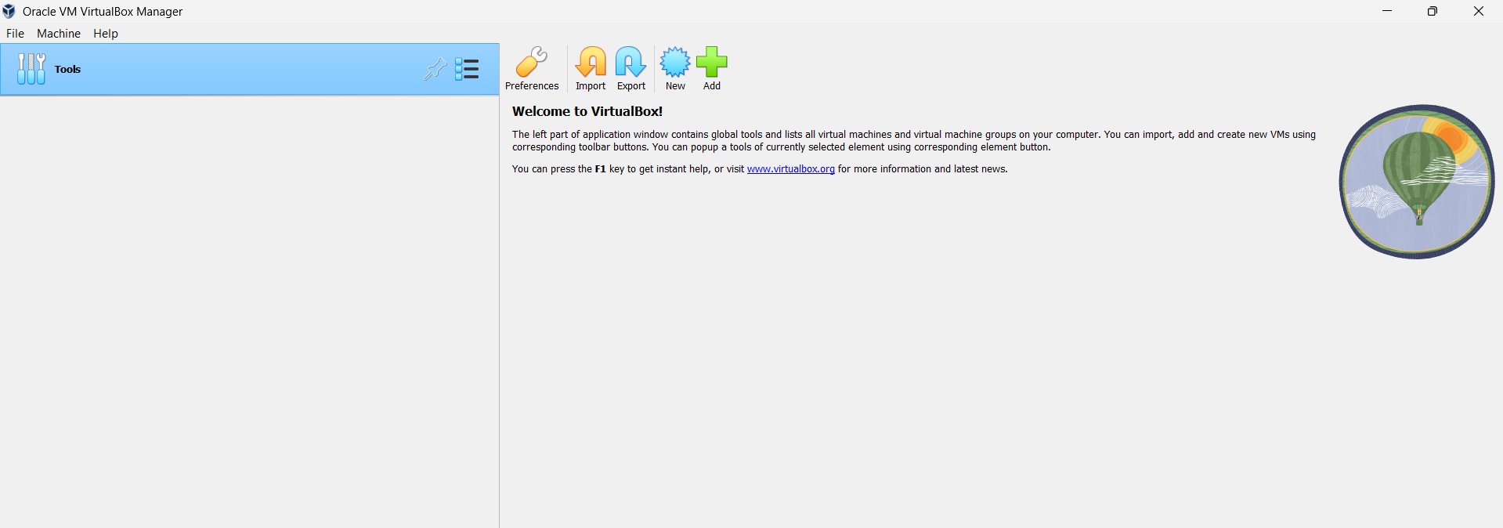
STEP 2: Create New VM
Click New
Name: Virtual Box Ex-6
Type: Linux
Version: Ubuntu (64-bit)
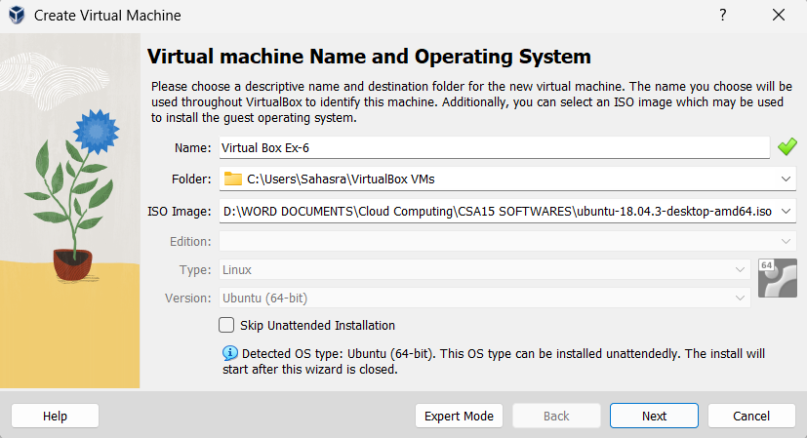
STEP 3: Select ISO File
Click ISO Image
Browse and select Ubuntu ISO
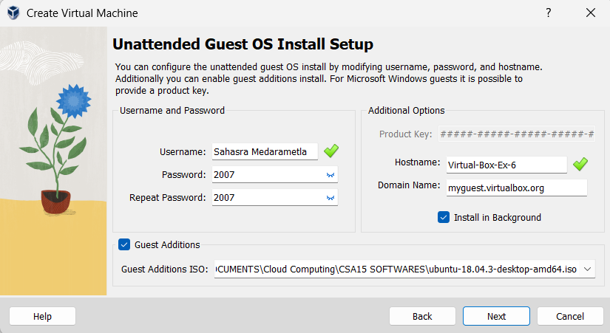
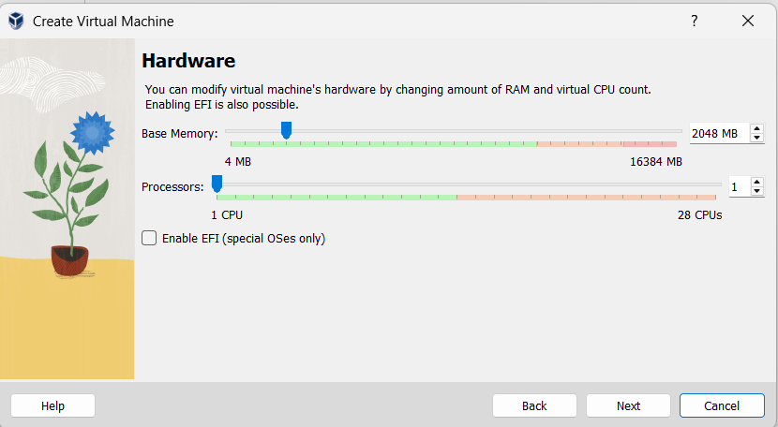

STEP 4: Finish Setup
Click Next → Finish
Click Start to run VM
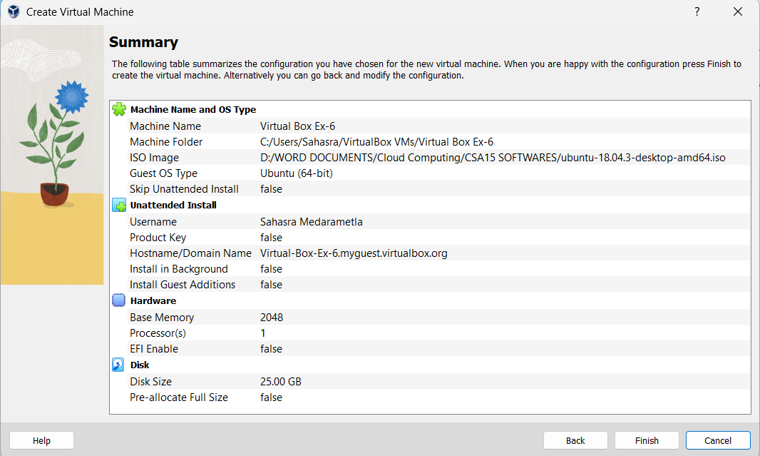
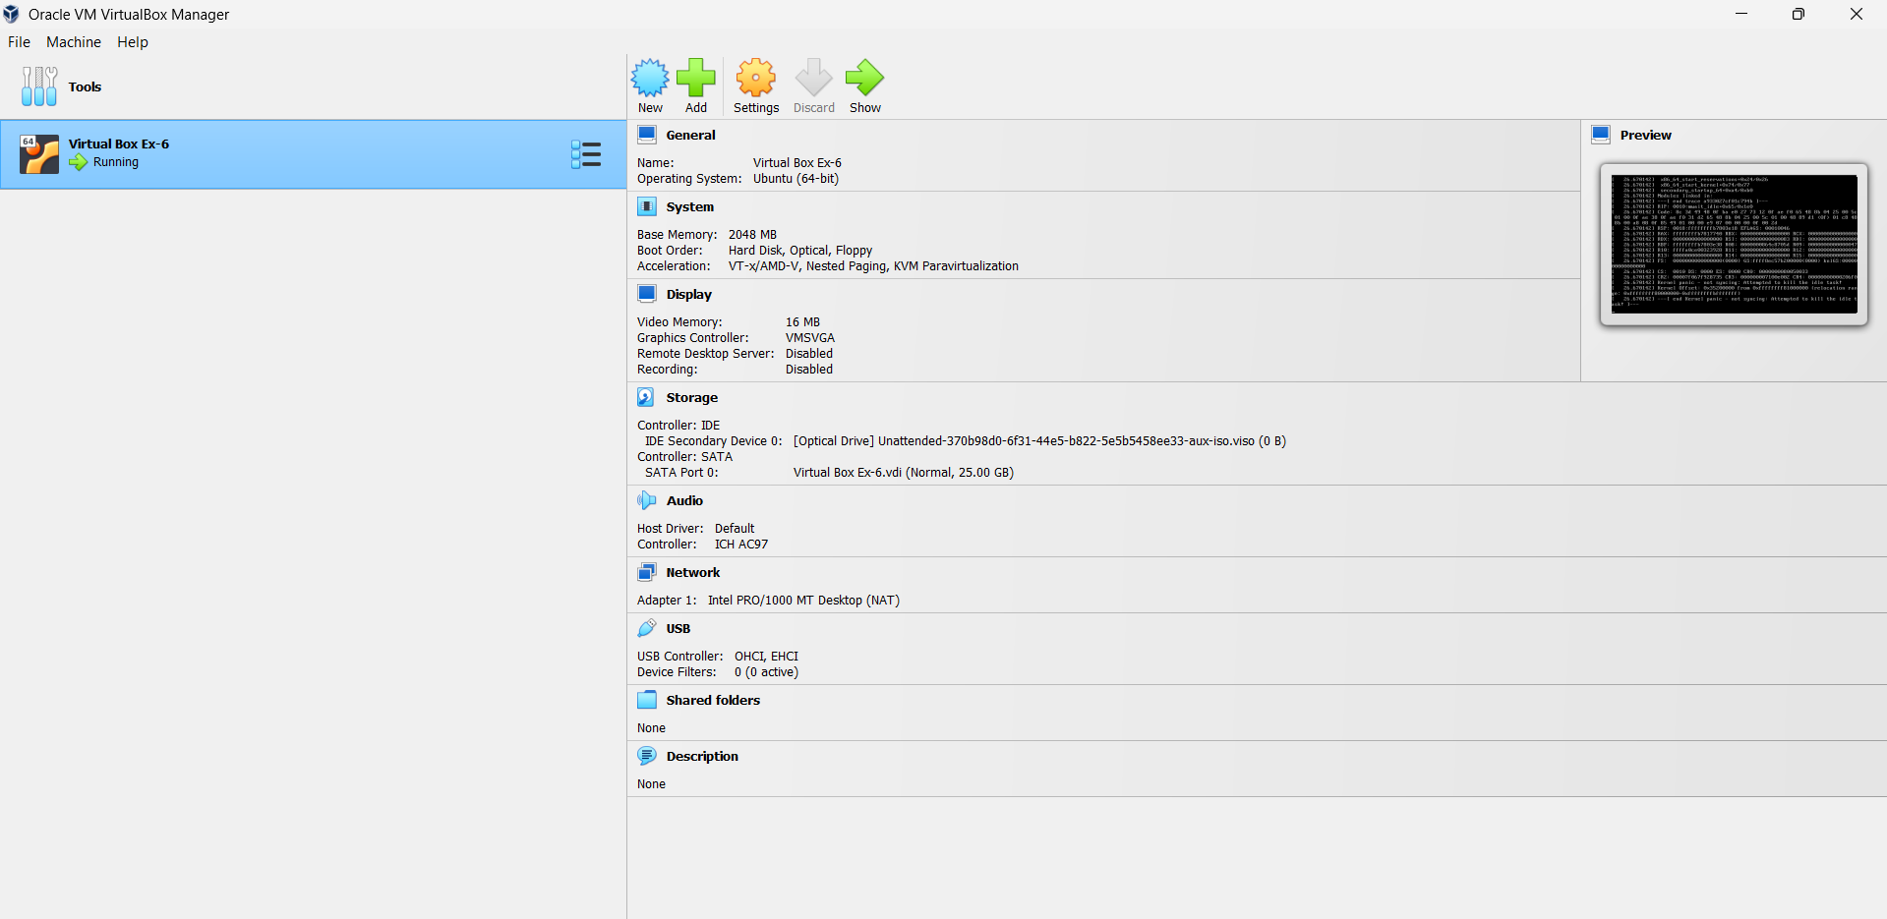
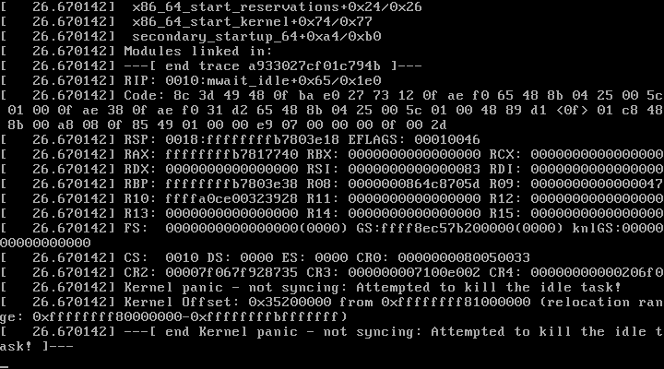

RESULT: Virtualization using Type-2 Hypervisor VirtualBox is demonstrated successfully.

